Course code: CSA1013 Name: S Jeena Princy
Course: Software engineering Reg no.: 192572058

RAPTOR

1. Using RAPTOR, draw and validate a flowchart to find the factorial of a given positive integer. The program should accept an integer n as input and compute n! using a loop. Finally, display the factorial of the given number.
Aim: To draw and validate a RAPTOR flowchart to find the factorial of a given positive integer using a loop and display the result.
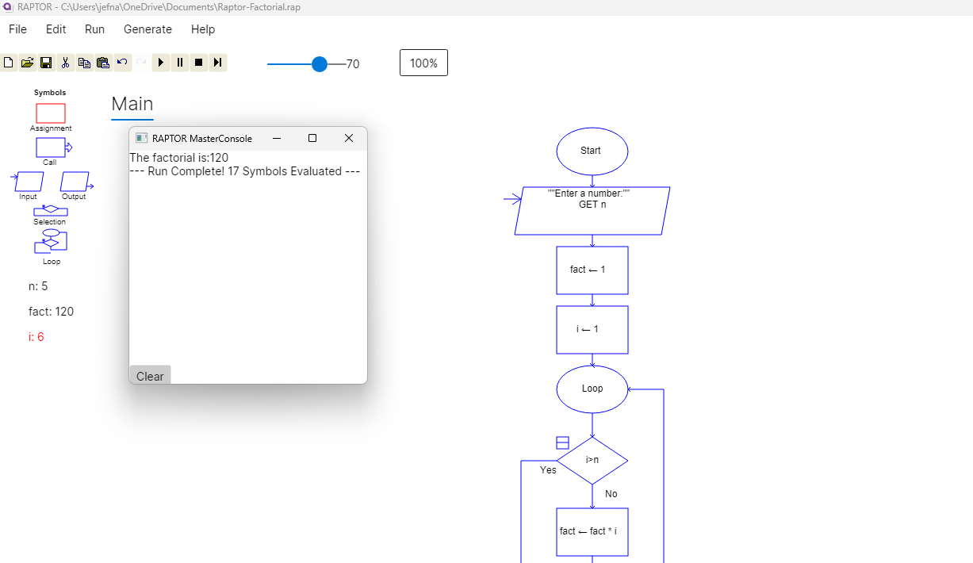
Output:

Result: The RAPTOR flowchart was successfully drawn and validated. The program correctly calculates and displays the factorial of the given input number.

2. Using RAPTOR, draw and validate a flowchart to check whether a given number is an Armstrong number or not.
Aim: To draw and validate a RAPTOR flowchart to check whether a given number is an Armstrong number.
Output:
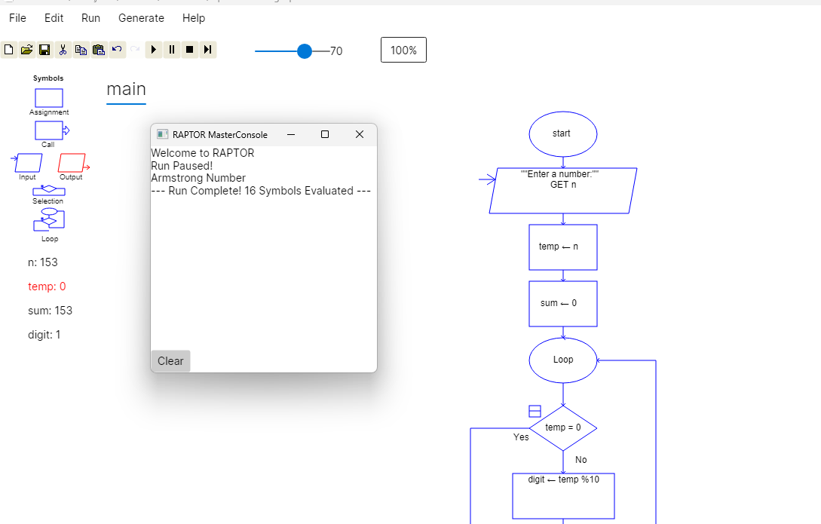

Result: The RAPTOR flowchart was successfully executed and it correctly identified whether the given number is an Armstrong number or not.

3. Using RAPTOR, draw and validate a flowchart to find the greatest among three given numbers.
Aim: To draw and validate a RAPTOR flowchart to find the greatest of three given numbers using decision-making statements.
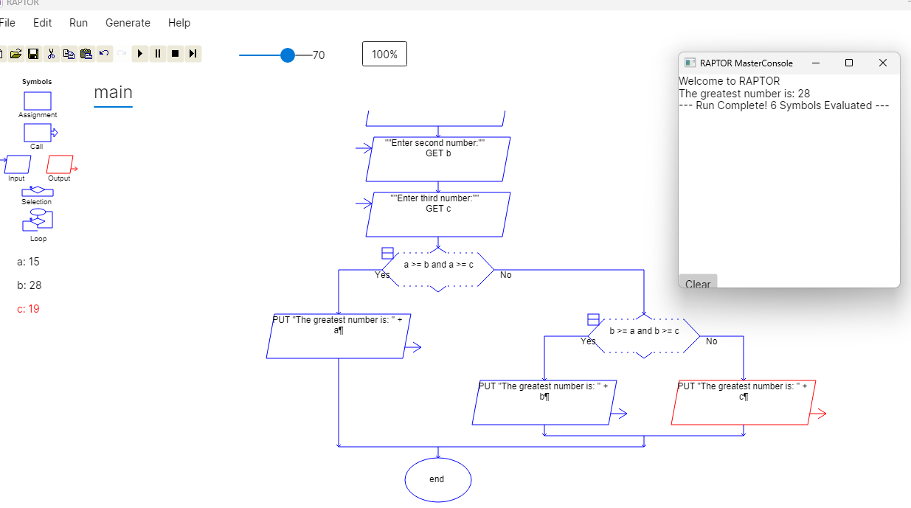
Output:

Result: The RAPTOR flowchart was successfully drawn and validated. The program correctly finds and displays the greatest among the three given numbers.

4. Cyclomatic Complexity in Software Testing is a testing metric used for measuring the complexity of a software program. It is a quantitative measure of independent paths in the source code of a software program. Cyclomatic complexity can be calculated by using control flow graphs or with respect to functions, modules, methods or classes within a software program. Cyclomatic complexity for a flow graph G is V(G)=E-N+2. Cyclomatic complexity is a software metric (measurement), used to indicate the complexity of a program, Cyclomatic complexity = E - N +P where, E = number of edges in the flow graph, N = number of nodes in the flow graph, P = number of nodes that have exit points. Find Cyclomatic Complexity for a graph having number of edges as 17, number of nodes as 13 and number of predicate nodes in the flow graph as 5.
Aim: To draw and validate a RAPTOR flowchart to calculate the Cyclomatic Complexity of a software program using the formula:
Cyclomatic Complexity = E-N+P
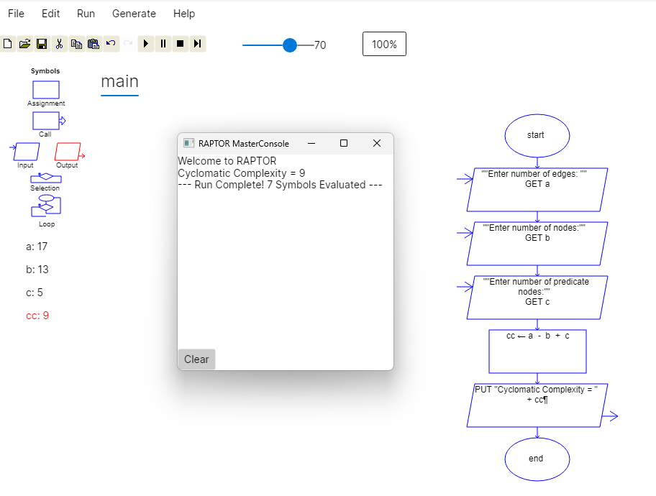
Output:

Result: The RAPTOR flowchart was successfully drawn and validated. The Cyclomatic Complexity of the given flow graph was calculated correctly.

